**Problem Statement: There can be multiple customers, who can place multiple orders on the site. Now a sales person can handle these orders will distribute into multiple sales persons (One order will be assign to one salesperson only). So a sales person can have multiple orders of multiple customers**

1. **Create Database**    
      
   **Sol 1:** 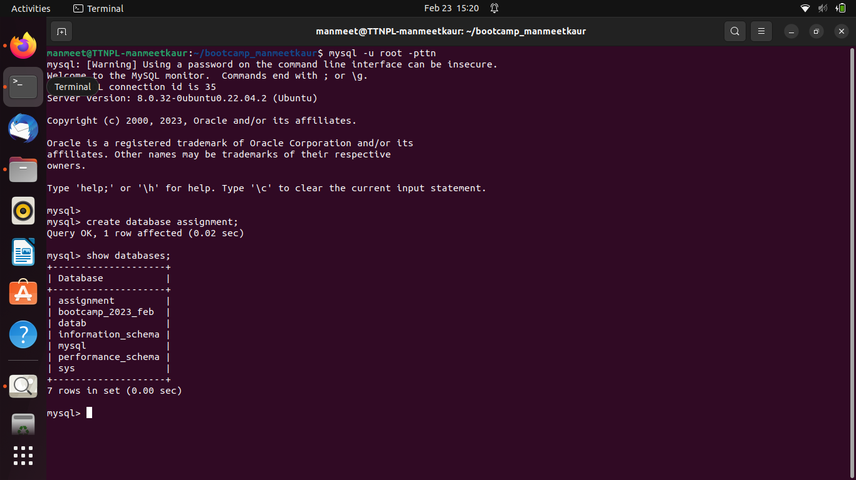
2. **Design Schema**    
      
   **Sol 2:** 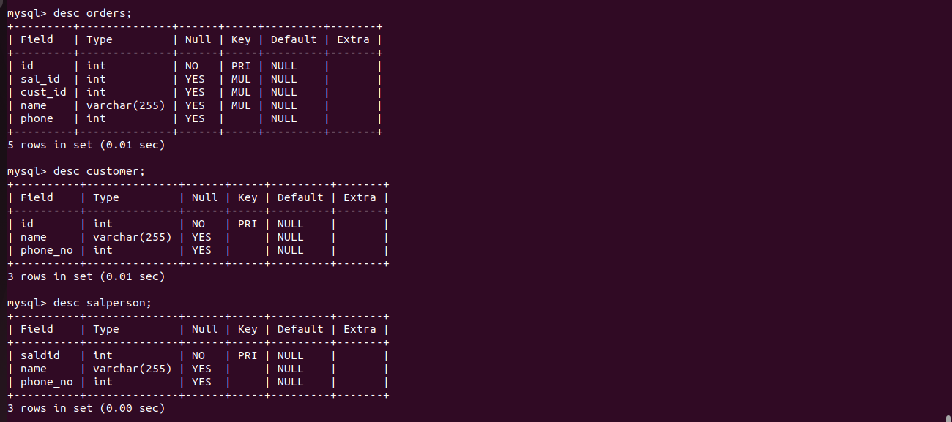
3. **Create tables**    
      
   **Sol 3: a.** Orders Table



**b.** Customer Table



**c .** Salesperson Table  


**4. Insert sample data**

**Sol 4:**

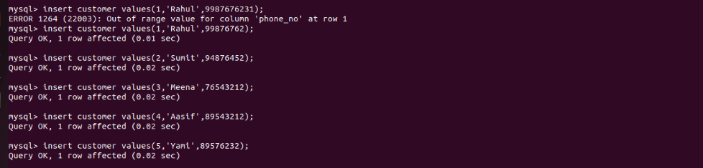

**5. Find the sales person have multiple orders.**

**Sol 5:**

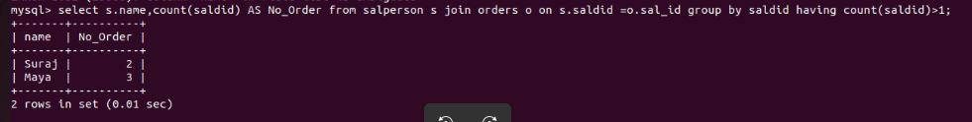

**6. Find the all sales person details along with order details**

**Sol 6:**

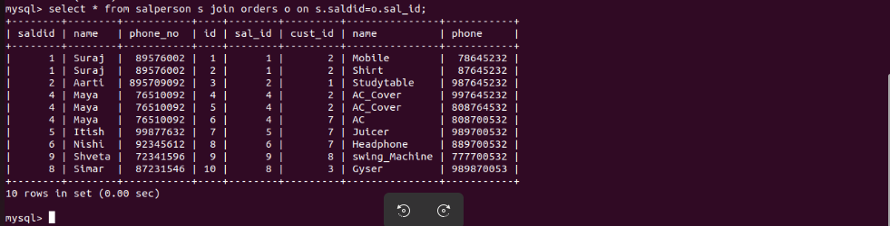

**7. Create index**

**Sol 7:**

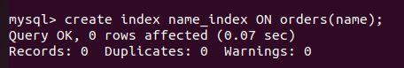

**8. How to show index on a table**

**Sol 8:**

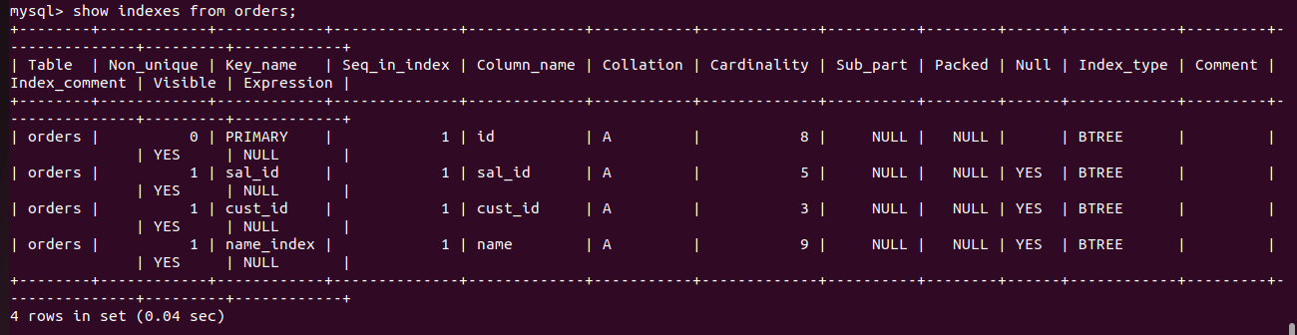

**9. Find the order number, sale person name, along with the customer to whom that order belongs to**

**Sol 9:**

